2+4G Acquisition Equipment Instructions
- This device is hardware configured as GSM two carriers, two carriers support GSM900, GSM1800 optional, LTE one carrier, carrier supports band8 band7 band3 frequency points can be configured. The device is powered by 220V AC.

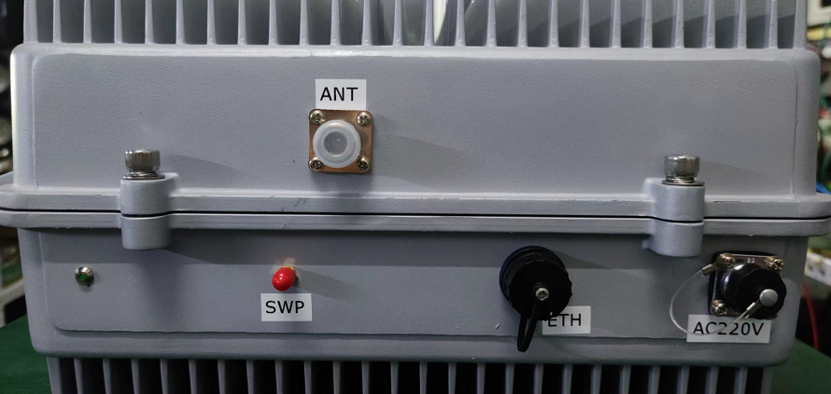
ANT is connected to any port of the panel antenna through a coaxial cable to ensure the tightness of the connector.
SWP glue stick antenna
ETH is connected to the computer, the computer system needs to be win7 or above
AC220V connected to socket via power cord
- The front of the antenna needs to face the open and densely populated place, and there are no buildings, trees, metal, and glass blocks in front of the antenna.
- The computer is connected to ETH through a network cable, and the computer IP is changed to a fixed IP: 192.168.1.111; if the computer has a firewall, it needs to be turned off.
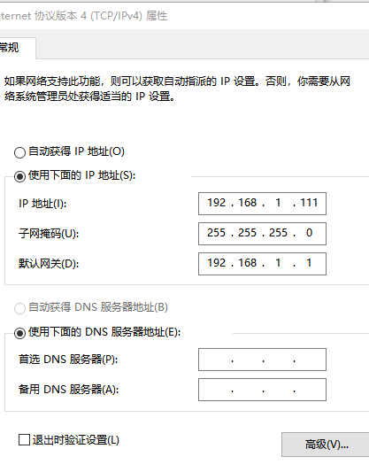
- Open the software 2G4GTool.exe
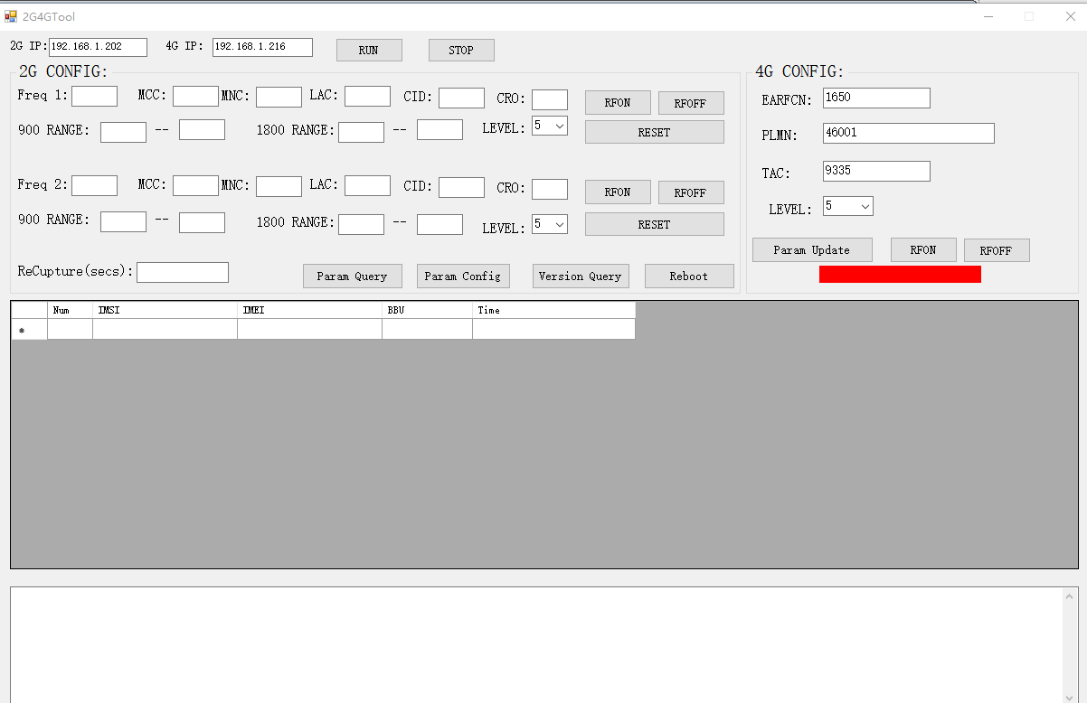
- , Open the software and click "RUN"
- , Click "Param Query" to query the configuration parameters of the 2G baseband board
- The parameters that need to be paid attention to in 2G are "Freq 1" and "Freq 2", which correspond to MCC and MNC respectively, which need to be consistent with the parameters of the operator.
- , "LEVEL", is the power level, 5 is the maximum, 1 is the minimum;
- , "Param Config", parameter setting, after changing the parameter, you need to click to download it to the board, and it will take effect in real time.
- , 4G baseband board will be automatically connected to the host computer software. Wait until the red signal light turns green, indicating that the 4G baseband board can work normally
- , The "EARFCN" and "PLMN" of the 4G baseband board need to be configured to be consistent with the operator. Click "Param Update" to download the configuration to the board, and it will take effect in real time. PLMN is MCCMNC, the picture is 46001, EARFCN is 1650
